

COMMUNITY COLLEGE OF CITY UNIVERSITY

DIVISION OF APPLIED SCIENCE AND TECHNOLOGY

AST20613 Computer System Development

2014-2015

G.V. Calendar

(Google Voice Calendar)

PROJECT PLAN

by

Group:ISD02

WONG, Ho Long(53587834)*

LI, Sing Lun (53612386)

SIN, Sin Chung(53587350)

WONG, Chun Kit(53581516)

Supervised by

Dr. Timothy Kwong

**Project Environment**

Name of Project: G.V. Calendar

Type of product: Web Development

Course Code: AST20613

Course Name: Computer System Development

Supervisor: Dr.Timothy Kwong

Group Number: ISD02

Group Leader: WONG, Ho Long (53587834)

Group Members: LI, Sing Lun (53612386)

SIN, Sin Chung (53587350)

WONG, Chun Kit (53581516)

# **ACKNOWLEDGEMENTS**

We have taken efforts in this project, it would not have been possible without the kind help and support of many individuals and organizations. We would like to take this chance to extend our sincere thanks of all of them.

We are very thankful to our supervisor, Dr.Timothy Kwong, the guide of the project that help us to solve many problems throughout the project. Also, we are highly indebted for his guidance and constant supervision as well as for providing necessary information regarding the project and also for his support in completing the project. Moreover, his kind concern provides much power to our team to finish the project successfully.

We would also like to express our special gratitude and thanks to the teachers who have taught us in these two years. The knowledge they have taught us is very useful in this project and it helps to fix lots of issues.

The teachers that we owe a great many thanks are: (Names are listed in alphabetical order)

Dr. Desmond Tsoi

Mr. Frank Lau

Mr. Jackie Kwong

Dr. Kenny Ma

Dr. Timothy Kwong

We would also like to thank you all of our groupmates, with all the help and support for doing the development of the project.

Thank you.

Yours sincerely,

Wong Ho Long, Li Sing Lun, Chan Kin Chung, Sin Sin Chung, Wong Chun Kit

FYP ISD-02 G.V. Calendar

**Table of Contents**

**Acknowledgements**

**Abstract**

**1. Introduction**

1.1 Background

1.2 Objective

1.3 Scope

1.4 Reason of developing this application

1.5 Assumptions

1.6 Limitation of existing application

1.7 Target user

1.8 Report outline

**2. System function**

2.1 Overview

2.2 Client side

2.3 Server side

**3. System development**

**4. Responsibilities and Management**

4.1 Organ**i**zational Chart

4.2 Responsibilities

4.3 Project Deliverables

**5. Resources and Budget**

5.1 Hardware

5.2 Software

5.3 Budget

**6. Risk Management**

6.1 Technique Risk

6.2 Schedule Risk

6.3 Assumption Risk

**7.References**

**GANTT table**

**ABSTRACT**

The population of portable device is growing gradually especially throughout these year, portable device may become replaced postion of Computer or laptops, Not only the student studied in IT field, but also other streams of students usually use portable device in their daily life. Therefore our aims of our project is developing tools for useful managing their life by portable device friendly. Perhaps our project will try to use CSS3 and HTML5 for designing the layout of website, CSS3 and HTML5 are the too use for development.

These tools most update function included flexible property and also animation function, slider function etc, with database application for development such as MySQL. Our group are confident that our development tools will cater all requirements of portable device users indeed.

By ISD02 in 2014-2015

**1.1. Background**

Nowadays, we can see lots of Hong Kong people using their smart devices such as smart phones, tablets at any time. With the great popularity of smart products, those devices have become part of their live and they cannot live with it. The aim of those smart products is to facilitate people live and make their life become convenient. People can finish their jobs or obtain the specific information easily in a short period of time by using those smart devices and so the number of people using smart products is increasing sharply in recent years.

Besides, why those smart devices can improve people’s life or get the job done easily? First of all, smart devices are portable. People can bring it outside and use it in any places with a light afford, they can put it on their bags or just take it by hand. With the compare of traditional desktop computer or notebook, smart devices are smaller in size and lighter in weight. Also, the design of smart devices fits human’s hand so people can hold it easily and use it for a long time. Secondly, with the aid of physical size of portable devices, people can obtain information or complete a specific job easily at outdoor. For example, people can search the nearby restaurants, the review of the restaurants, the address of shops or sending emails at anywhere by using smart devices. People can obtain what they want in a simple gesture of finger. Thirdly, the functions provided by apps in smart devices can bring a bunch of useful tools that can get the job done easily. Usually, there is a bunch of specific functions in a specific app and it helps a specific task. People can install a number of apps and help them to do a list of jobs. Therefore, with the trend of smart devices, more and more company develops apps for their brand as it is a way to help to earn money. In general, the apps that require to pay can provide the functions that other apps do not have or it provides a specific function in an abundant way.

However, although there is a lot of app in the market, most of the apps cannot provide a complete function for a high scope of users. Some of the user may need a specific function from the app and the app does not have it. In a serious situation, there are no apps that provide those specific functions to satisfy the specific group of people’s needs. Moreover, some of the famous applications only provide a brunch of basic functions and they do not have the functions that are used for the people who are disabled or some special situations. With the issue mentioned above, we would like to complete some of the functions missed in a specific app to make the app more perfect. The details of the project will be discussed in the later section.

**1.2. Objective**

In general, we would like to focus on a specific app called Google Calendar. The project would introduce Voice Recognition engine to obtain users’ input and output the information from the calendar. Secondly, we would introduce the QR code system to obtain .ics file and input the information inside the .ics file into the calendar. Thirdly, a chat section is introduced to facilitate the communication between users. Forthly, we can let the users to change the background of the calendar. Finally, a pointer spot is introduced into the calendar for human finger.

In general, this project has five objectives and they are listed below.

1. Solving the problems that people will face in specific situations such as in a crowded MTR or other transportations, driving, those people who do not want to use their eyes to see the monitor of the devices.
2. To facilitate the use for blind people.
3. As Google Calendar is a famous application, the functions mentioned above should be included.
4. A famous application should provide a more complete function in any situations that cause any inconvenience.
5. A more user-friendly and configurable UI should be used.

We have seen that the calendar provided by Google cannot satisfy some of the needs of users in daily life. In general, we see that people will face the problems on viewing the calendar when their hands are not “free”. The Voice Recognition engine can enhance the situation they meet. Also, the system can provide a more convenient way to check the schedule on users’ calendar. In the side of UI design, we should provide more settings to users to configure the application and make it more user-friendly.

# **1.3 SCOPE**

As we all know, people use the Google Calendar frequently but they need to use their eyes and hands to control it. They cannot use Google Calendar when they are doing others things. It causes inconvenience. For example, people cannot view their calendar during driving or working at the same time.

In order to make the Google Calendar to be more convenient and cater to universal usability, the following listed out some of the features that we aim to include in GV Calendar to solve the problems and inconvenience that those target users encounter.

**Remark:These are only the short-listed function description and introduction of function,the detailed function had illustrated in later pages.(Section 2)**

**1.Voice output system**

use voice commands to input event in users schedule, for cater to users with color blindness and the users who are busy.

**2.Highlight for what had read aloud**

The users easily frustrated that when the AI had read aloud, there had no indication for users what had read aloud, the users would failed for listening some main point due to various of reasons, it is compulsory for users for check for what had said.

**3. Skipped Option for listening tapes**

The skipped option is likely to use that the listening tap is quite long for all users to listening whole times, difference from reading that could directly focus on the specific point immediately. Therefore, skipped option is a techniques for user chosen the timeslot that they like to listen.

**4.Background picture setted for users liked**

The background picture setted may beneficial for users interest, imagine the users wake up in one days, and their timetables should matches the interest of contemporary users, especially for users are emotionism.

**5.Refresh function for users timetables**

Low memory and low ability of phone, users may usually got lost for the information that not update. Therefore refresh function had helped the information updated eventually and prevent version compulsion

**6.Setting the pointer for guidance the users views**

The users usually lost in touch while seen large amounts and array of datum, therefore a pointer may set for pointing the things that user browsing on and clarify the view of users.

**1.4 Reasons of Developing this Application**

As most of the people will use calendar to check or mark their schedule frequently, or even use it daily, a user-friendly and complete functions should be included in the calendar. If more useful functions are included in the calendar, more users will use it instead of using traditional paper calendar and thus it can saves the user of paper.

Moreover, there is no solution for the blindness or some specific situations in using calendar. The project can provide some of the solutions to improve and fix the problems in different situations and scope of people.

Therefore, we decide to introduce more functions for the existing Google calendar that can improve the life of different users and help them to finish the job in a easier and comfortable way.

**1.5 Assumptions**

A few assumptions have been made during developing this application.

1. Every user who uses this web application has a computer or smartphone with browser
2. Every user who uses this web application has a network connection
3. Every user who uses this web application has Google account
4. Every user who uses this web application is using Google Chrome browser to browse the website.
5. Every visually impaired users can browse website to use this web application
6. Add friends function’s target is//Only this web application users can add friends

**1.6 Limitations of Existing Application**

**1.6.1 Google Calendar**

An application for Google Calendar is widespread, it seems become the most popular calendar among the competitor. However, there are many functions had gave a high rating from users. However,there are certain of functions may be more user friendly and adapt much better for cater universal usability to all users.

The priority arrangement for nowadays Google Calendar could make color blindness patient frustrates while used it, although the color chosen is full of diversity for people chosen for set the importances of among works. However the users cannot see the color arrangement, the users may defined wrong and it made make a big trouble for users.

But also the second distinctive advantage maybe the crowed users may feel frustrated for reading the timetable around chaos, therefore Google Calendar cannot satisfy the requirement of those users.

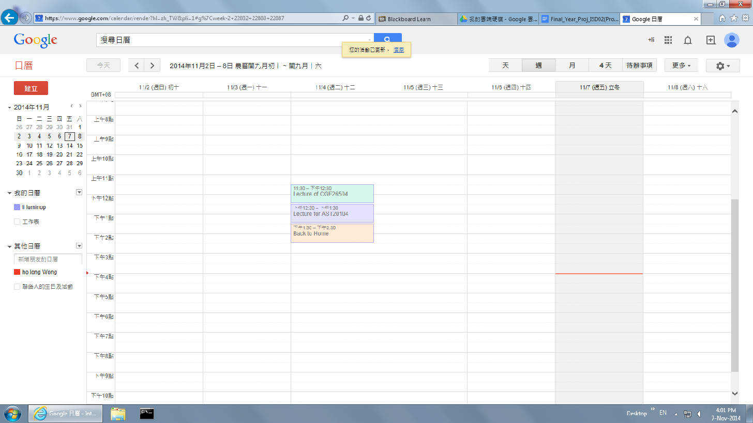

**Figure 1.1** Google Calendar’s user interface and priority of things provided and arranged, the color blindness patients quite difficult for determine the colors effectively

**1.6.2 Voice Calendar**

Voice Calendar is an application of Google Play. It is an calendar with voice input functions. Users can add schedules in their own calendar.

**Figure 1.2**

**Voice Calendar UI**

There are few limitation Voice Calendar has.

First, It is platform independent. Voice Calendar only can be used in Android OS mobile. Other Operation Systems(OS) devices cannot use this application.

Second, It only provide voice input function(add calendar). It without calendar speak out function. It is not take care of visually impaired people at all.

Third, In this application’s voice input function, after users speak out what they want. The system will generate the schedule form with information automatically, but users still need to press “done” button. It is not good for visually impaired user.

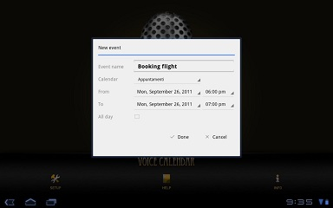

**Figure 1.3 Voice Calendar UI of adding event**

Fourth, This application need to be paid by users for using. Not all people can use this application.

Lastly, This application have no import or outport calendar file(.ics extension file). It is not high portability in iCalendar. Users hard to add existing iCalendar into their application. Users also hard to add it calendar into other iCalendar.

**1.7 Target Users**

Users of Google Calendar and visually impaired people are the main target users of this application.

**1.7.1 Google Calendar’s users**

Google Calendar’s users can use browser access to this web application in order to make use of Google Calendar in their life more easy. They can use the function of Google Calendar more efficiency and comfortable. It can save them some time and more willing to use the system.

This application can help them accessing to Google Calendar.

This application is an interface between users and Google Calendar. Users can use all functions of Google Calendar, such as display Calendar information, add friends calendar, add event into calendar. And additional function can be used, such as voice system, user can add or browse event in their Google Calendar. These function can reduce user time to see calendar, quickly achieve users goal. Users no need to look their Google Calendar schedule, but can still get the information that they want. User can browse their timetable when they are driving or not convenient to see their calendar.

**1.7.2 Visually impaired people**

Google Calendar is designed for normal people to use. Google Calendar cannot take care of people that having visual impaired. Visually impaired people have a right to use electronic calendar. Google Calendar required users have visual ability. It is not cater to universal usability enough.

For visual impaired people, some of them using a large print calendar, some of them using voice recorder to record their schedule and some of them need relatives to remind them. This application can change their daily life. Visually impaired user can use iCalendar smoothly.

**1.8 Report Outline**

In the next chapter, it is the overview of the features that GV Calendar will be given. This chapter is mainly divided into two parts, which describe about the features provided by the web page and the feature of the server that help the web page to store the data or information for the users.

In Chapter 3, reasons of choosing which version of operating system we choose and reasons of CS6 we chosen rather than others such CS5 or CS4. This chapter also listed out the the tools we need to use for developing this web application project. Moreover, it will give a brief information on the project team’s organization and their responsibilities.

For the Chapter 4, the resources, the hardware and the software we need to use for this project will be listed out. Also, the budgets of this project will be also given out.

For the final chapter, it will mention all the risks what we will face and the solutions how to solve it on doing this project.

**2 SYSTEM FUNCTION**

**2.1 Overview**

While developing the web application, it can be divided into two parts, which are web page side and server side. For the web page side, it will mainly focus on the displaying the features provided by the web application; while the server side will store and handle the information of user and the data of database.

**System Context Diagram (SCD)**

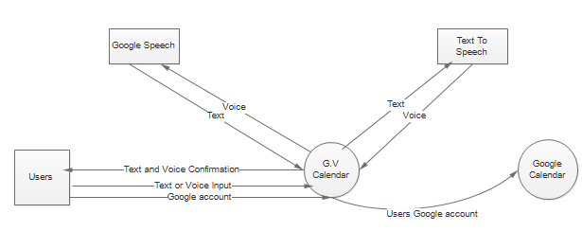

**2.2 Client Side**

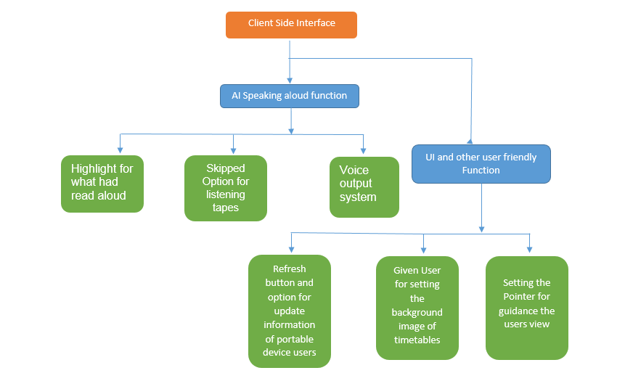

**Figure 2.1:The figure illustrate the main web page function planned**

**Features Description**

The application includes many features, the following listed out features that can help user of Google Calendar to increase the efficiency and convenience of using Google Calendar.

**A.AI Speaking Aloud Function**

**Voice output function**

Voice output function mainly for converting the text to speech file, for cater different users usage that who are busy and in the crowded situation that might not check interface immediately. From these, user through this output function for listen schedule rather than read. Whatmore, the users may be have visual problems for reading the timetable such as color blindness, which their sensitive of color are not sharp and strong, then they may detected wrong the color and it might formed big troubles at all. Just imagine that the users are businessman with colorblindness, the wrong detection of color may lead them missed a priority for grouping things. Therefore, It’s compulsory for setting listening AI function for users listening the tapes they could like to listen.

**Highlight for what could had said aloud**

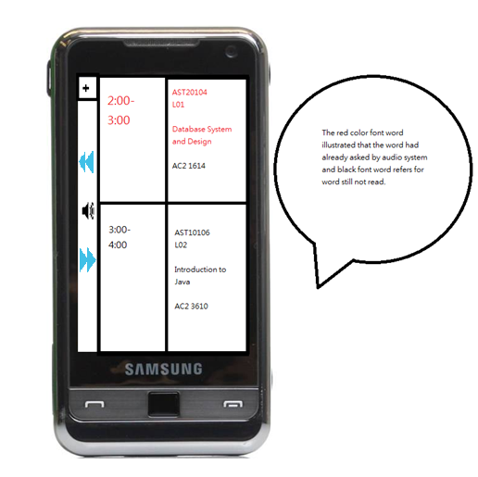

**Figure 2.2:The graph had illustrated which word had said aloud and which words not and also skipped option button for blue color quoted**

The users may skipped some important things and issues due to many reasons maybe too crowded and too chaos for condition. Both color blindness users and users are in crowded place may felt frustrated for skipping the content that they listened. However the users could likely to check the actual things for timetable written rather than only listening. However, searching time is expensive for crowded users especially. Users may lost direction or need many times for refocus direction that they may felt tired in the early morning. Hence, Through indication, the users would not skipped the content, and kept the content‘s structure well.

**Skipped Option for listening tape**

The skipped option is used for users might be useful for users likely to skipped the option for sometimes they may known position of time slot and what things would do on that time, or maybe the users wanted to check its against but didn‘t want to see the screen and inconvenience for watching the screen. Therefore, skipped option would provides a greatest choice for that type of users.

**B.UI and other user friendly function**

**Background picture for setting**

Users are felt dull in the whole day morning, due to they may wake up morning, the emotion are highly depressed in that times. However, through background picture setted, by which setting background photo that users liked, it‘s a good action for increased the happiness for users.

**Refresh button for portable device users**

It‘s well known that the portable devices that usually have a lower memory and lower efficiency due to their limited size and they couldn't ensure they would got stable Network connection at time. It’s obvious that the size of file is huge and large, hence the loading and system refresh is usually lower than the computer users, while the update is incomplete, the information may got wrong for users. Therefore, refresh button may act as a substantial role that ensure the information got in touch and update at all.

**Setting the Pointer for guidance the user ‘s view**

The users may usually get lost from among various of datum and array of time slots, If the user could likely to checked information immediately and a certain of data had settled for a day of timeslot. Therefore, pointer may easily for guidance and separate the views of users from among of datum, the user may felt less frustrate for what they had sighted, and easily focus on their tasks.

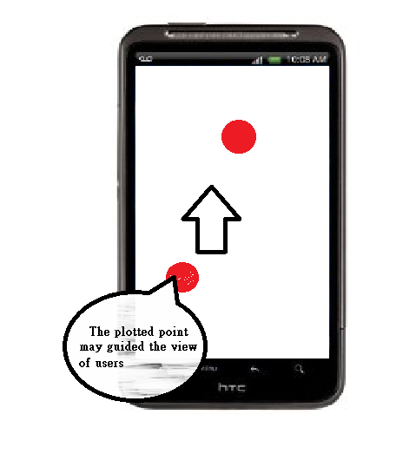

**Figure 2.3:Plotted spot may guide the users view and useful for user ‘s reading**

**2.3 Server Side**

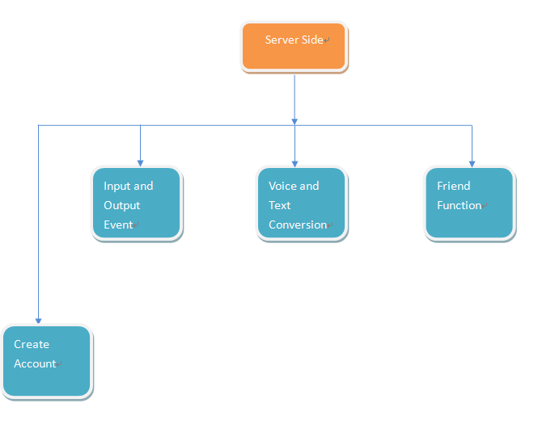

**Figure 2.4:The figure illustrate the main server function planned**

**Create Account**

Although this application using user’s google account, we still need to create a account in server side for Identity. In this process, the account name will be the same as google account and link these two account. This account will save many things, included voice message (these sound file cannot save to google side), friend relationship, etc.

**Input Event**

User and decide to input their event by inputting text or voice. For input by text, server will transfer those text and input to client’s google calendar. For input by voice, the voice file will save at our server, The title of event will input to google calendar and the link of that sound file save in content side.

**Output Event**

There have two way to output event. First one is output the event in calendar according by UI design. Other one is output by voice. For the event inputed by text, server will get those event from google calendar and send back those text to client side for display. For event input by voice. When user on click of that event or want to get all schedule by voice, the request will send to server. For text schedule, server will convert the text to voice and send the sound file back. For voice schedule, server will get the sound file from database and send it to client side.

**Friend**

**Add Friend**

To use some function such as integrate other user’s timetable to show common available time. Users have to add friend via our UI. The request will send to their gmail for confirming. After user’s target confirm it, a relation will build. Also, server will remind the target user to add the original user to be friend.

(Notice: Get calendar request from friend is single direction event. Which mean the target user can not see the original user’s calendar)

**Voice-text Conversion**

For those function in client side,which need to convert voice to text or text to voice. These request will send to server with some text for processing identification.

**Convert text to voice**

After client send text to server for converting, server will convert the text to a .wav sound file. Then server will convert the wav file to mp3 file to reduce the file size. After the process server will send back the mp3 file to client side for playing.

**Convert voice to text**

For some people that cant input their event to the calendar by typing. We provided a function that user can input their event by voice.

When server received the sound file, it will send this file out to google speech to convert the sound file to text. Then the server will use these text to do processing such as input event.

3 System Development

Operation Environment of project maybe as follow illustrated, and hopefully development method would followed these style as possible:

|  |  |
| --- | --- |
| Operating System | HTML base system design |
| Hardware Requirement | Vostro 3900 PC  Android Mobile Phone |
| Operation Software | HTML Language  HTML5 Language  CSS  CSS3  JavaScript  MySQL  Java(Eclispe)  LAME MP3  C++(May not be helpful for developing)  C#  Visual Studio 2013 Professional |
| Server | MySQL |
| Platform for performance | Dreamweaver developed by Adobe Company for CSS/CSS3,HTML,HTML5    Java Development Toolkit (JDK) useful for enhance java environment.    Oracle Language support for MySQL and database system development |

System Relation and Explanation

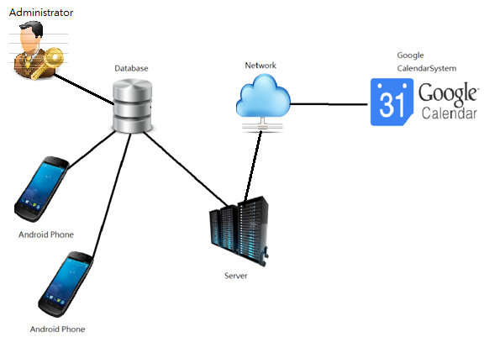

**Figure 3.1:The graph had illustrates the relation between servers,users,administrator and database**

The graph had illustrate the relation for procedure rundown, it consist of server, user and database. Server is a place for placing the hardware and tools with standard, however the database is used for storing certain datum with arrangement, When the client required for the information, the database then could transmitted the information that user indeeds respectively.

Moreover, the information got from google calendar system should be illustrated,that directly connected with google calendar system with server through networking.

Administrators have a role for controlling and administering the Database’s data flow and information respectively.

Development tool and Comparison:

**Microsoft Speech Platform – Software Development Kit**



It is a useful software for converting the text file to sound files with standard quality, With nearest Version 5.1, there could have full of diversity of voice and language for chosen, Compare with other TTS Console Application in the market share, Microsoft Speech Platform still kept pioneered with competitor.

The second charming from Speech SDK may come from the text to speech tool could have a grammatical correction function,by which reducing the opportunity for getting the errors. Likewise, it‘s a user friendly behavior

[PromptBuilder](http://msdn.microsoft.com/en-us/library/microsoft.speech.synthesis.promptbuilder(v=office.14).aspx) class is easily for control the class speech output, [Speech Synthesis Markup Language (SSML)](http://go.microsoft.com/fwlink/?LinkId=201763), files containing text or SSML markup, and prerecorded audio files. [PromptBuilder](http://msdn.microsoft.com/en-us/library/microsoft.speech.synthesis.promptbuilder(v=office.14).aspx) also given an opportunity that for choosing voice that you like and also rate and volume. For author content much better, SSML-compliant XML, which provides a full range of authoring technique and also allows you to select and control speaking voices.

The competitor of Speech SDK come from different aspects, Ultra Hal TTS Reader, naturalReader are also common tools for input the voice, however these tools only supporting the language with specific types(NO Chinese and Cantonese for chosen). Therefore, it makes Microsoft stood out from various of choices.

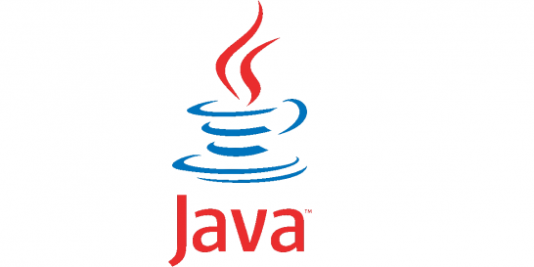

Java(Eclispe)

A Programming tools that support for Java Development Toolkit (JDK) environment, useful for development a function for Java, java application such useful for programming task in web development



C#(Visual Studio Professional)

Visual Studio Professional 2013 is a programming tool for supporting C# environment,useful for development a function for TTS Application specially.



LAME MP3 Encoder

It‘s a useful tool for converting the WAV file recorded and produced from TTS Console Application to MP3 File size, it‘s highly reduced file size respectively due to the fact that although Quality of WAV file is much better, the memory size of file is too high that not suitable for nowaday users for download.

Standard size of WAV file is approximately 44000 bitrate that for improved sound much better, however due to the fact that the sounds file may not be reused and the reason for listening maybe just for checking the information accuracy but not for enjoyed high quality of music. However,through MP3, it mainly rely on nearly 256 kps memory, yet it ‘s eight times while compared with wav file size required. Therefore, LAME MP3 paid a lot of affords for helping user for reduced usage of memory.

(Reference :http://www.freestockmusic.com/audio-formats/)

Here comes a comparison of WAV and MP3 File

|  |  |  |
| --- | --- | --- |
| Comparison | MP3 | WAV |
| Memory required | Less(256 kbps) | More(about 44000 bit rates) |
| Quality of sound file | Lower | Standardized as CD Quality |
| Smoothy | Lossy | Lossless |
| Durability | Easily have a distortion | Much Durable |

MySQL Enterprise edition

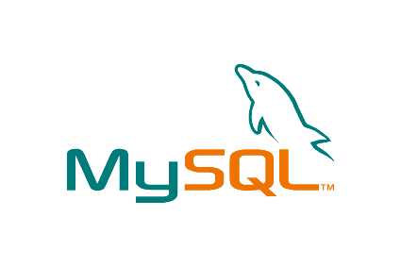

Used for database programming, the tools is useful for manipulating data and managing data with SQL Code. However, due to for commercial use(development of project) rather than Individual use, some may consumed.

MySQL Cost and our recommendation using development software:

|  |  |  |  |
| --- | --- | --- | --- |
| Name of function | MySQL Enterprise Edition | MySQL Standard Edition | MySQL Cluster Carrier Grade Edition |
| MySQL Cost | Medium | Lowest | Highest |
| MySQL Database Server |  |  |  |
| MySQL Security and Encryption (Important for developloging system) |  |  |  |
| Storage Engine: NDB(Not Useful) |  |  |  |
| Overall Prefer Version |  |  |  |

Dreamweaver CS6 Version

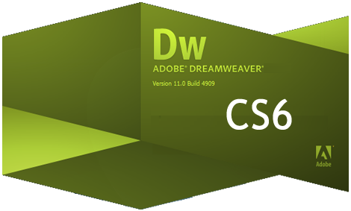

Dreamweaver is a tools for manipulating the Web layout design such as CSS and Html, design tool throughout the websites. The CS6 could also support the CSS3, PHP and HTML5 Function.

Why choosing HTML CS6 rather than other CS5/4/3/2/1:

|  |  |
| --- | --- |
| Advantage |  |
| 1. CSS3 and HTML5 don ‘t need using plugin anymore in CS6 | 5.Design mode could modified to more and more portable device oriented design |
| 2.Live View are much faster and reduced procedures | 6. UI Design for giving the people easily for selection. |
| 3.Business Catalysis Connective |  |
| 4.Better Integration for adapt in Dreamweaver by Photoshop or Illustration technique |  |

It’s, Therefore, its force us from develop the tools by using CS6 rather than other development language through advantage as below illustrated.



ASP.NET is a web programming language,most probably in these project we could mainly using for handled http request from websites for using ashx, which ashx is lacken the User interface design, the main principle of ASHX is for recieved certain of things and then through characterisitc of thing s recieved and then return somethings to client side.

Google Chrome



It ‘s a portable web browser for support diverse of authority language such as CSS3, Html5 and also support with different properties of web designs. such as flex properties for portable devices.

Opera Browser



Opera Browser mainly functionally dependence on Google, but the advantage of opera not only use less memory required while computer ran browser.

Market share of Browsers

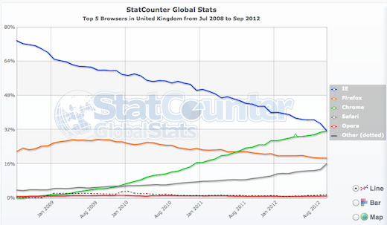

Fig3.2. The figure show the comparison on the usage of 5 browser from British.

The figure had provided the comparison of Window Browser for computer Users in British during 2008 to 2012, variety of browsers namely IE, Firefox, Chrome, Safari, Opera and Other respectively.

It‘s obvious observed from diagram that the expenditure for using IE declined gradually, yet usage of Chrome risen continuously, it ‘s interested to noticed that proportion of usage of IE and Chrome overlooked at Sep 2012.

IE kept dominant at the beginning, an exponentially plunged had observed between June 2009 and July 2009, While the proportion of usage declined gradually between June 2010 and Sep 2012, the number of Google Chrome users kept continuously increased.

Firefox, Safari and Opera, meanwhile, kept remain kept constant from period provided. It‘s forecast that the proportion of Chrome would increase in the future yet IE would decreased.

Microsoft Windows Server 2008

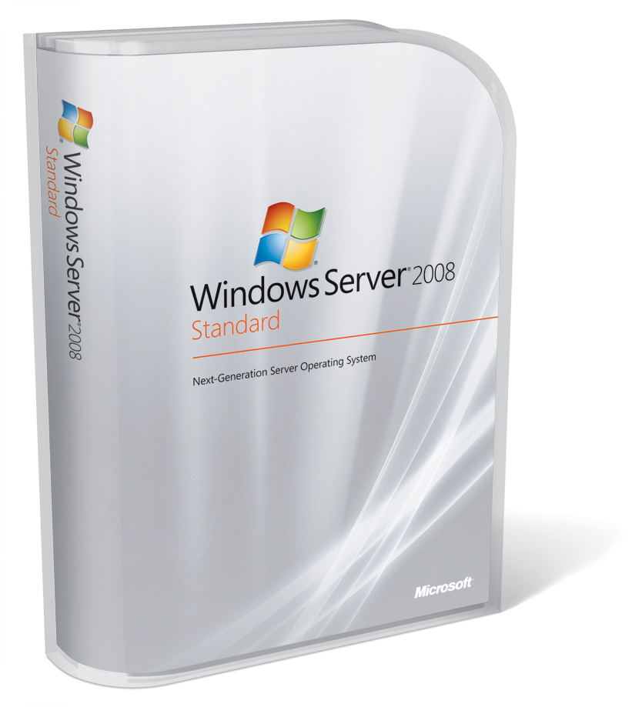

Window Server 2008

The charming of Window Server 2008 may varies from fully support for PHP language, which PHP is a computational language for managing the database well. Also WIM System for provided Engineer Oriented Developmental Environment for develop the platform.

We have good job of allocation for every member equally and every member knows about what they need to do. If problem arise, other group members who have finished

Comparison Popularity of Window Server 2008 and other

are the users of Window Server 2008. While Window Server share a highest proportion of market share, Window Server 2012, which is another Server Products produced by Microsoft, less than nearly 5% of computer users used it for Server. Likewise, Linux is also not popular and common use for market, with approximately 2% of market share. Unknown and Other, meanwhile, became the lowest proportion of market share, the latter and former only cover less than 1.5%.

**4 Responsibilities and Management**

**4.1. Organizational Chart**

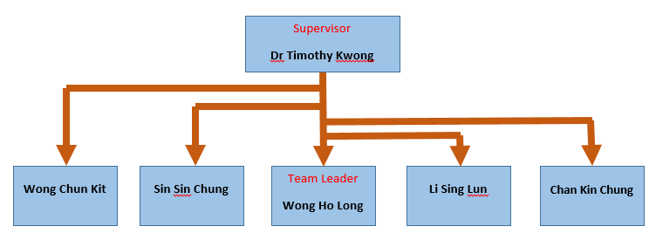

**Figure 3.4.**Organizational chart of the developing team

The above figure showed the organization of the group which is developing the voice system timetable. As shown above, Dr Timothy Kwong is our supervisor and Wong Ho Long is our team leader.

**4.2. Responsibilities**

The following table listed out the responsibilities of each member.

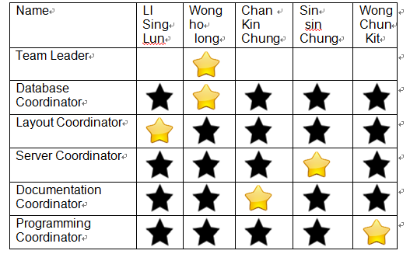

Remark: Yellow Star is refer for in charge person, black star is represent deputy in charge person

**4.3. Project Deliverables**

The table below showed the date of submission of the required items that needed to be delivered.

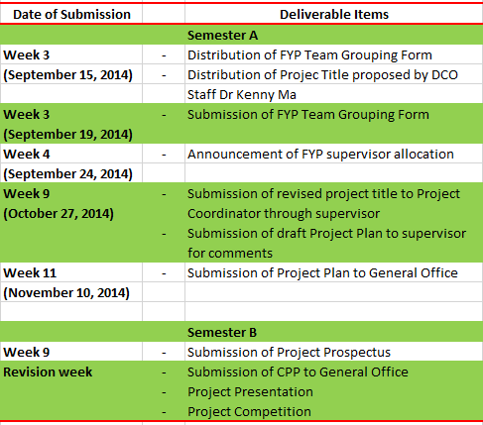

**Figure** Chart that listed out the deliverables for the project

5 Resources and Budget

**5.1 Hardware**

|  |  |
| --- | --- |
| **Model** | *Vostro 3900 by Dell Computer*  *(i5 4460 processor,4GB DDR3 MEMORY)* |
| **Operating System** | *Microsoft Server 2008 R2 Standard* |
| **Price** | HK$ 4288 |

Vostro 3900 by Dell Computer is chosen as the server for the project and it is used to storing the necessary data and process a specific task for users. It has an i5 CPU, 4GB DDR3 memory and it should be powerful enough to process the main tasks of the project and handle a high volume of traffic data.

**5.2 Software**

|  |  |
| --- | --- |
| **Name** | *Eclipse* |
| **Purpose** | Program Coding |
| **Price** | HK$ 0 |

Eclipse is used for coding and it is a famous coding software among the market as it is easy to use. The cost of Eclipse is completely free of charge and it is a open-source software.

|  |  |
| --- | --- |
| **Name** | *Visual Studio 2013 Professional* |
| **Purpose** | Program Coding |
| **Price** | HK$ 4506 |

Visual Studio 2013 Professional is chosen for the coding of C++ language as it provide more abundant functions and UI. The cost is HK$ 4506 for buying a copy of professional license.

|  |  |
| --- | --- |
| **Name** | *MySQL Enterprise Edition* |
| **Purpose** | Database System |
| **Price** | HK$ 15511 |

MySQL Enterprise Edition is used for the data system and it is used to manage the database in the server. The cost is HK$ 15511 for buying a copy of Enterprise license.

|  |  |
| --- | --- |
| **Name** | *Dreamweaver CS6 Version* |
| **Purpose** | Web Language coding |
| **Price** | HK$ 3730 |

For the part of web language coding (HTML5, CSS), Dreamweaver CS6 Version is chosen. As Dreamweaver is the famous software that used in organising the web page and coding the web language, it will be used. The cost of buying the license of it is HK$ 3730.

|  |  |
| --- | --- |
| **Name** | *Google Chrome Explorer + Opera Explorer* |
| **Purpose** | Testing |
| **Price** | HK$ 0 |

As we have to test the project, browsers are needed. Google Chrome and Opera will be used for testing. Google Chrome is one of the most famous browser for users so we will test on it. In contrast, Opera Explorer has less users and there is some issues in displaying content of webpage so we also test on it. The cost of both is HK$ 0, we just download it from the Internet.

|  |  |
| --- | --- |
| **Name** | *Microsoft Server 2008 R2 Standard* |
| **Purpose** | Operating System of Server |
| **Price** | HK$ 6438 |

Microsoft Server 2008 R2 Standard will be installed in the server as the operating system. The cost of it is HK$ 6438 in buying the license of it.

**5.3 Budget**

|  |  |
| --- | --- |
| **Item** | **Cost (HKD)** |
| *Eclipse* | $0 |
| *Visual Studio 2013 Professional* | $4506 |
| *MySQL Enterprise Edition* | $15511 |
| *Dreamweaver CS6 Version* | $3730 |
| *Vostro 3900 by Dell Computer*  *(i5 4460 processor,4GB DDR3 MEMORY)* | $4288 |
| *Google Chrome Explorer* | $0 |
| *Microsoft Server 2008 R2 Standard* | $6348 |
| *Opera Explorer(Prepare Use)* | $0 |
| *Total* | $34383 HKD |

The above table shows the total cost for developing this application.

The total cost for developing this application is HK$20,232.

6 Risk Management

6.1 Technique Risk

1. **Unfamiliarity of web applications**

Our group members are not familiar with web applications.

Available Solution

Some of the team members took a JavaScript and JQuery Summer Workshop that taught by Mr Jackie Kwong, so they can teach other team members some of the basic concepts of the JavaScript and JQuery library. Furthermore, we will borrow or buy some books to read to help us understanding web programming more.

6.2 Schedule Risk

1. **Keeping up with the schedule and progress**

This is the first time for our group to work on a big scale of project, our group is worried that we may not follow the schedule and progress because we have lots of other matters their tasks can give a helping hand by alleviating the workload.

Available Solution

We have divided our responsibilities equally and everyone knows their responsibilities. If there are problems appeared, other members who have finished their task can help to solve problems and share the workload.

1. **Making up time for meeting**

Every member of our group has different timetable. We are hard to find time to have meetings with supervisor. Also, we are hard to find other time to have meeting to talk about the project every week.

Available Solution

We use whatsapp to create a group and communicate with each other. Everyone sends the timetable in the group chatting room. All of us can know others’ timetable clearly. When one of our members want to make a meeting, he can see others’ timetable and provide available time to ask us to join the meeting.

6.3 Assumption Risk

1. **Failure of recognition**

There may be a chance that the Speech SDK may fail to recognize the voice command from the users what they want to do.

Available Solution

After users using the voice to input command, the system will output the words or commands that it recognized to the screen. It provides a chance for user to check the command is correct or not. Then, users can correct it by themselves or redo to input the voice again for the command once a time.

1. **Reference:**

1.SSL Table Show the market share of Window server.

*“The certificates in the July 2013 Netcraft SSL survey served over an SSL connection with a stapled OCSP response, split by operating system.” Retrieved November 5, 2014,*

*from http://news.netcraft.com/archives/2013/07/19/microsoft-achieves-world-domination-in-ocsp-stapling.html*

2.Stat Count Top Five Counter Web Browser in the UK. *Retrieved November 5, 2014, from* http://trak.in/wp-content/uploads/2010/08/BrowserMarketShare.jpg

3.Sound quality compared with MP3 and WAV. *Retrieved November 5, 2014, from* <http://www.noiseaddicts.com/2010/04/sound-test-difference-between-wav-vs-mp3/>

4.Comparison of Window Server 2008. *Retrieved November 5, 2014, from*

<http://powerwindows.files.wordpress.com/2010/07/07-26-10-exchange2010comparison.png>

[5.](http://powerwindows.files.wordpress.com/2010/07/07-26-10-exchange2010comparison.png) Voice Calendar - Google Play. *Retrieved November 5, 2014, from*

<https://play.google.com/store/apps/details?id=it.forbesluke.calendariovocale>

6.MySQL Link and Official Page. *Retrieved November 5, 2014, from*

<http://www.mysql.com/>

7.The Lame Project Official Page. *Retrieved November 5, 2014, from*

http://lame.sourceforge.net/

8.Dreamweaver CS6 Official Webpage. *Retrieved November 5, 2014, from*

<http://www.adobe.com/cfusion/tdrc/index.cfm?product=dreamweaver&loc=cn>

9.ASP.NET Official Webpage. *Retrieved November 5, 2014, from*

[http://www.asp.net/](http://www.adobe.com/cfusion/tdrc/index.cfm?product=dreamweaver&loc=cn)

10.Eclipse Official Page. *Retrieved November 5, 2014, from*

<https://www.eclipse.org/>

11.Chrome Official Webpage. *Retrieved November 5, 2014, from*

<https://www.google.com/chrome/browser/>

12.Microsoft Speech SDK Version 5.1. *Retrieved November 5, 2014, from*

<http://www.microsoft.com/en-us/download/details.aspx?id=10121>

13.Opera Browser Official Webpage. *Retrieved November 5, 2014, from*

<http://www.opera.com/>

14.Windows Server Official Site. *Retrieved November 5, 2014, from*

<http://www.microsoft.com/en-us/server-cloud/products/windows-server-2012-r2/default.aspx>

**GANTT TABLE**

In order to make the whole project more efficient, the project is divided into few parts. The following gantt table shows the details of the tasks.

